## EXPERIMENT 5: Using Nmap scanner to perform port scanning of various forms – ACK, SYN, FIN, NULL, XMAS

ACK-sA (TCP ACK scan)

Command: nmap -sA -T4 scanme.nmap.org

SYN (Stealth) Scan (-sS)

Command: nmap -p22,113,139 scanme.nmap.org

FIN Scan (-sF)

Command: nmap -sF -T4 para

NULL Scan (-sN)

Command: nmap –sN –p 22 scanme.nmap.org

XMAS Scan (-sX)

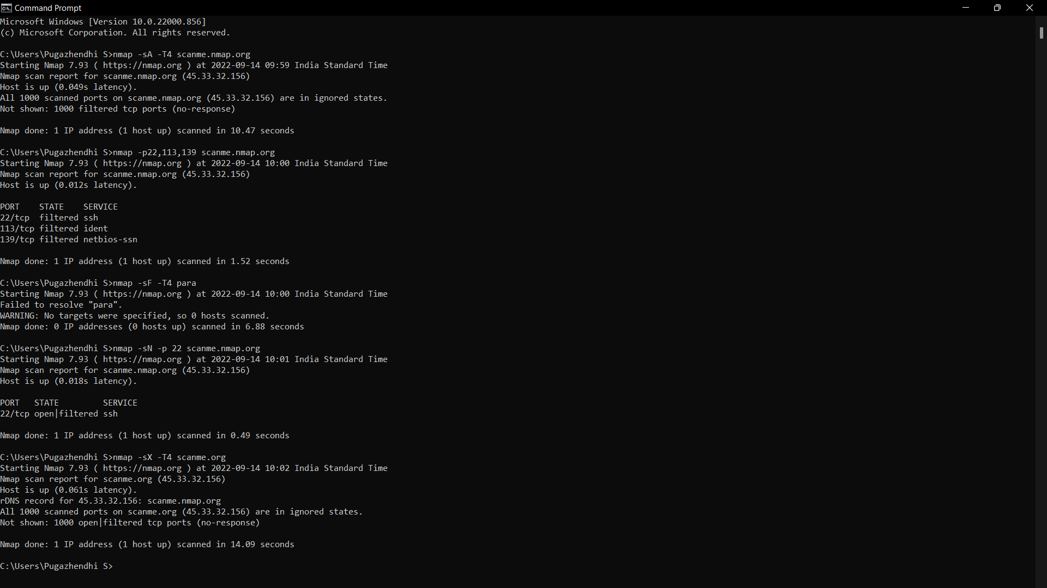Command: nmap -sX -T4 scanme.nmap.org